**HASHMAP DEMONSTRATOR**

***Working explained through examples below:-***

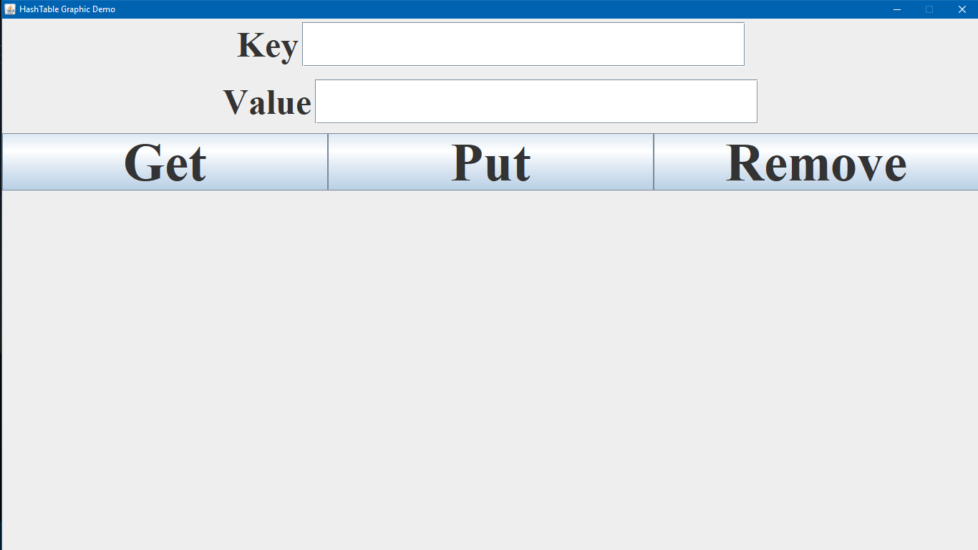

**Fig. SS_1 - Run the application**

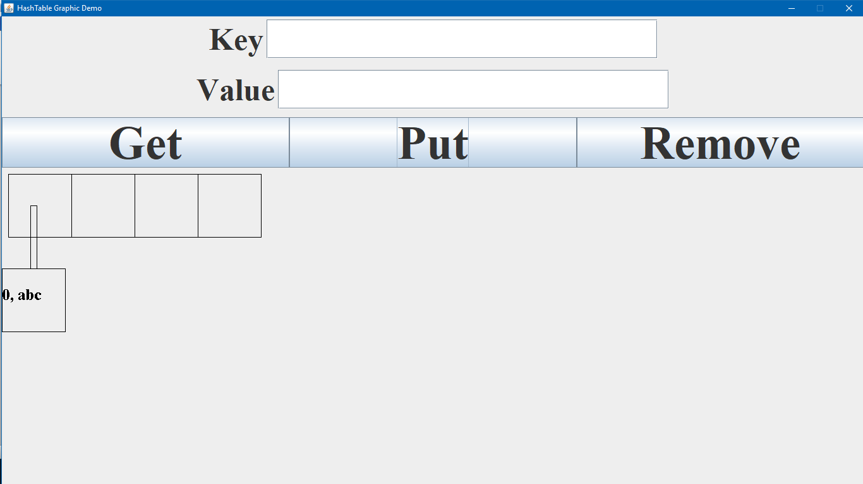

**Fig. SS_2 Put operation (Key = 0, Value = abc)**

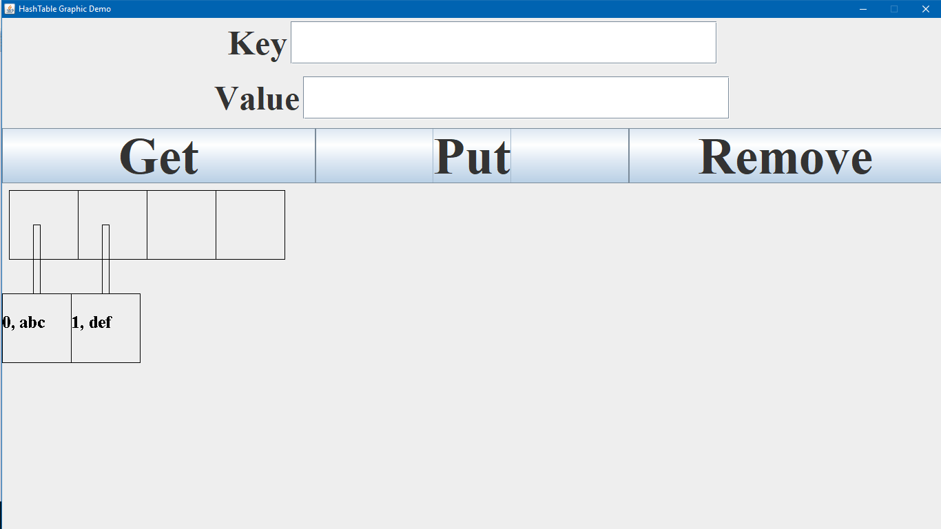

**Fig. SS_3 Put operation (Key = 1, Value = def)**

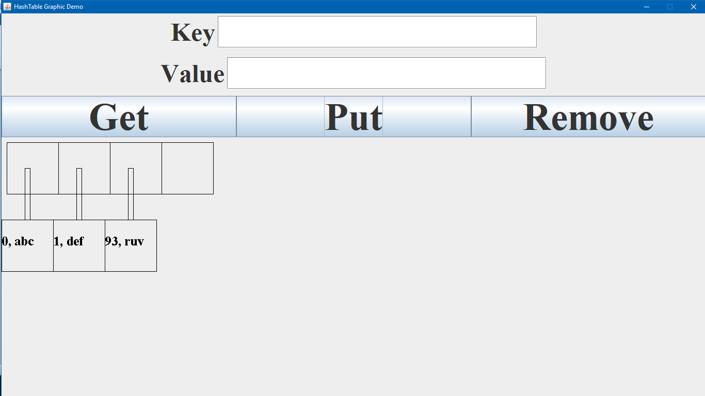

**Fig. SS_4 Put operation (Key = 93, Value = ruv)**

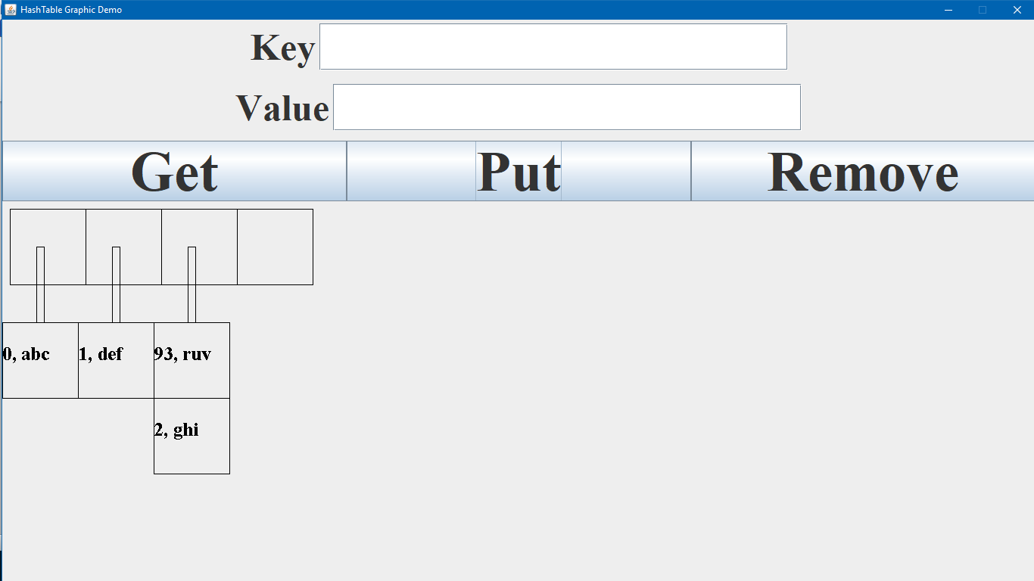

**Fig. SS_5 Put operation (Key = 2, Value = ghi)**

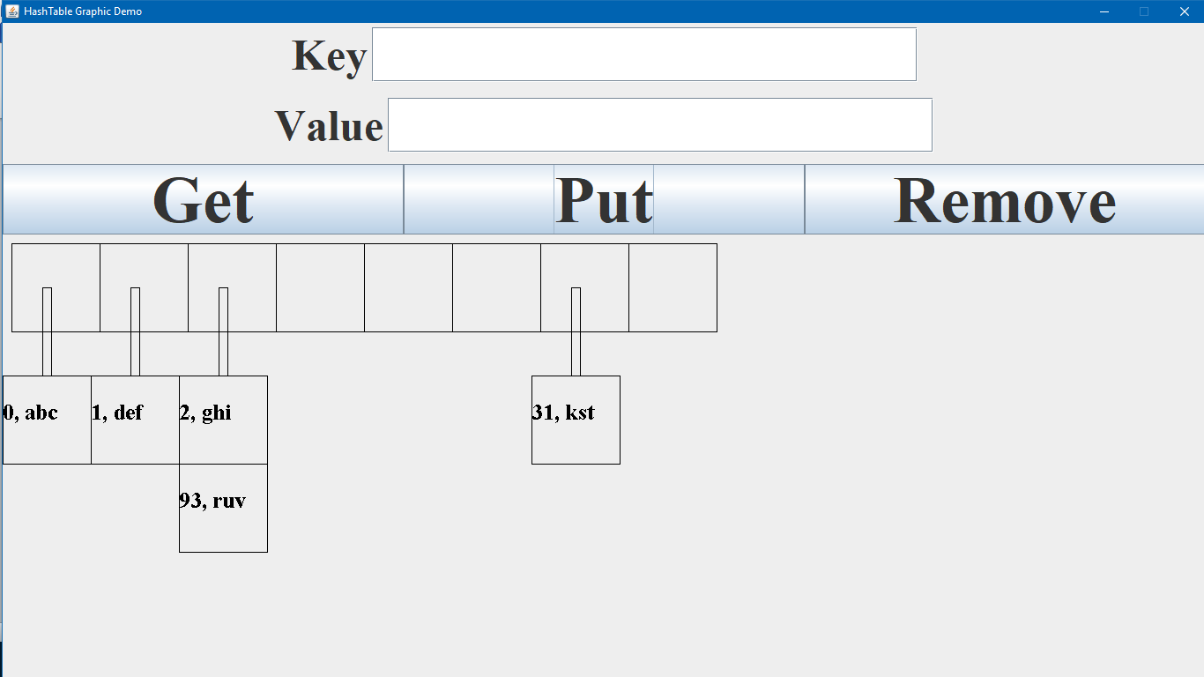

**Fig. SS_6 Put operation (Key = 31, Value = kst)**

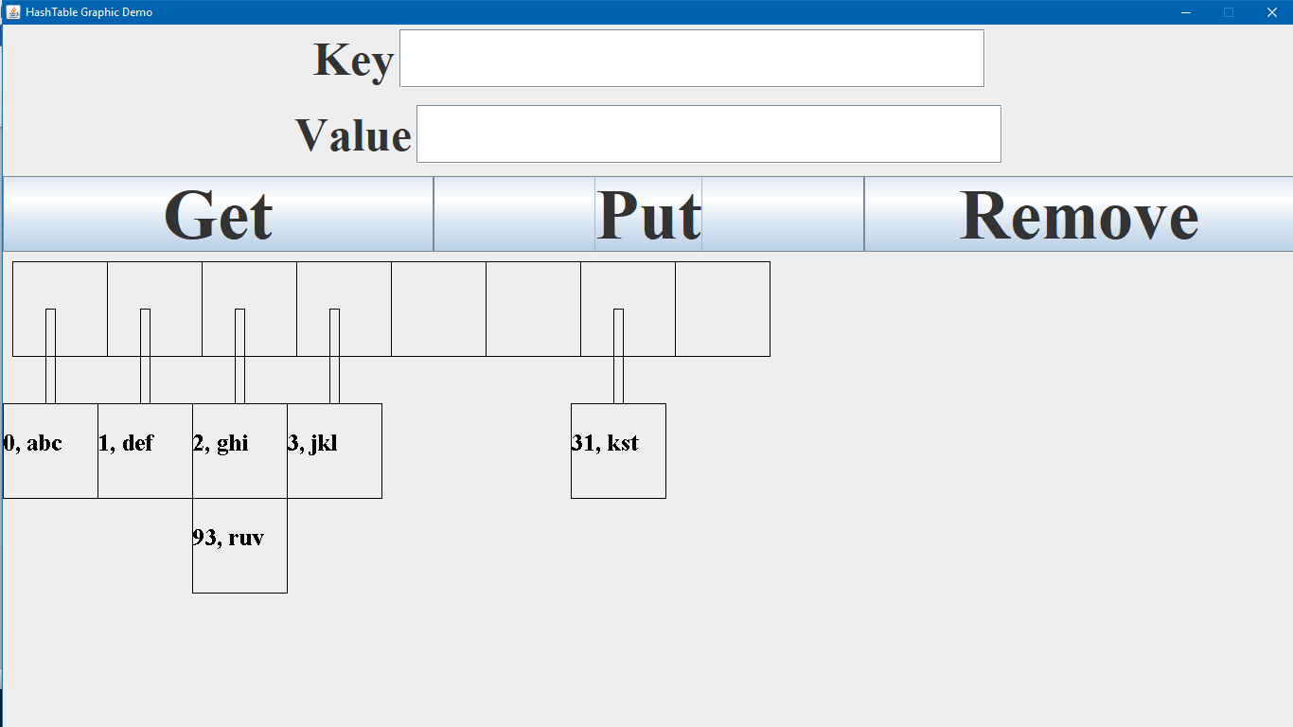

**Fig. SS_7 Put operation (Key = 3, Value = jkl)**

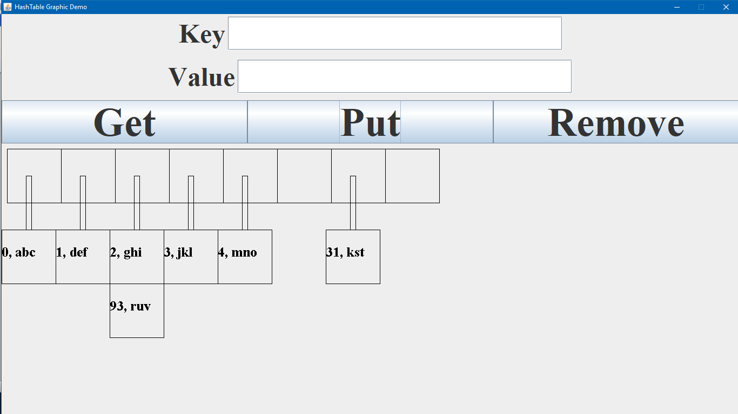

**Fig. SS_8 Put operation (Key = 4, Value = mno)**

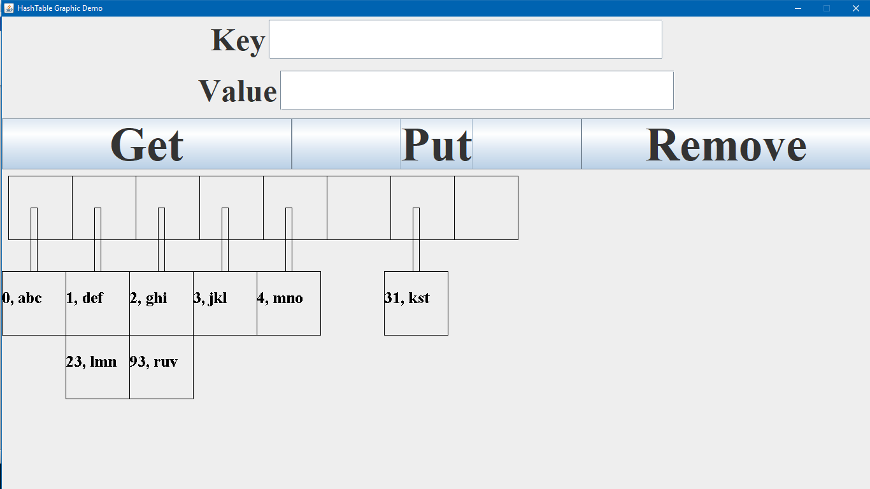

**Fig. SS_9 Put operation (Key = 23, Value = lmn)**

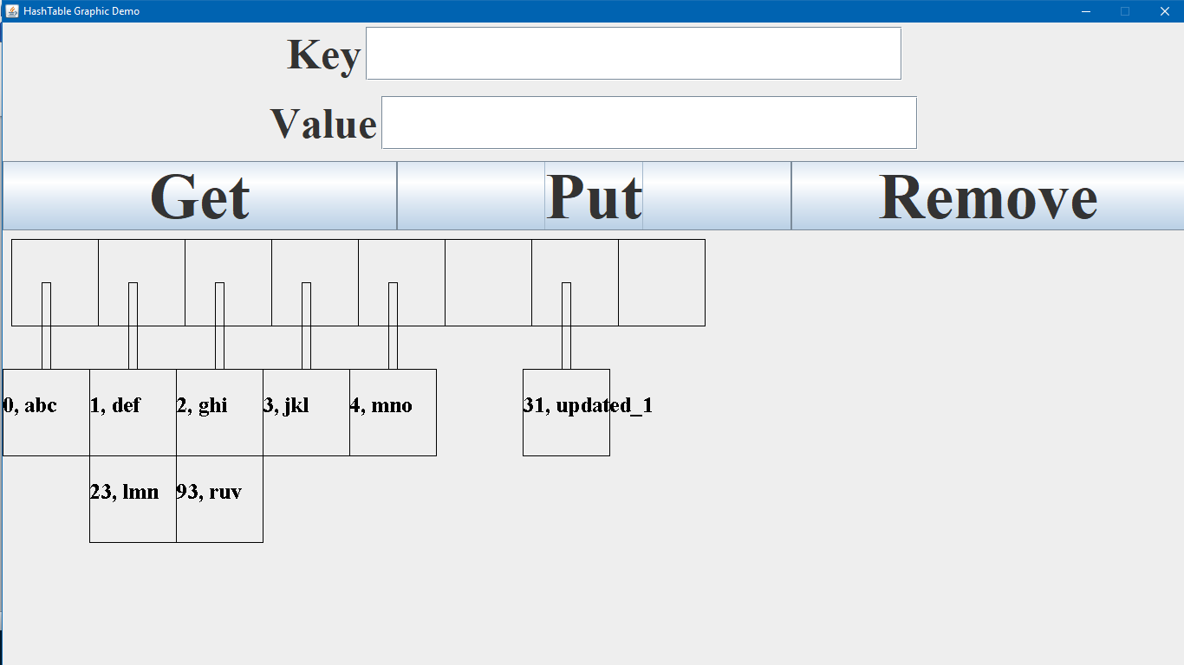

**Fig. SS_10 Put operation: Update value (Key = 31, Value = updated_1)**

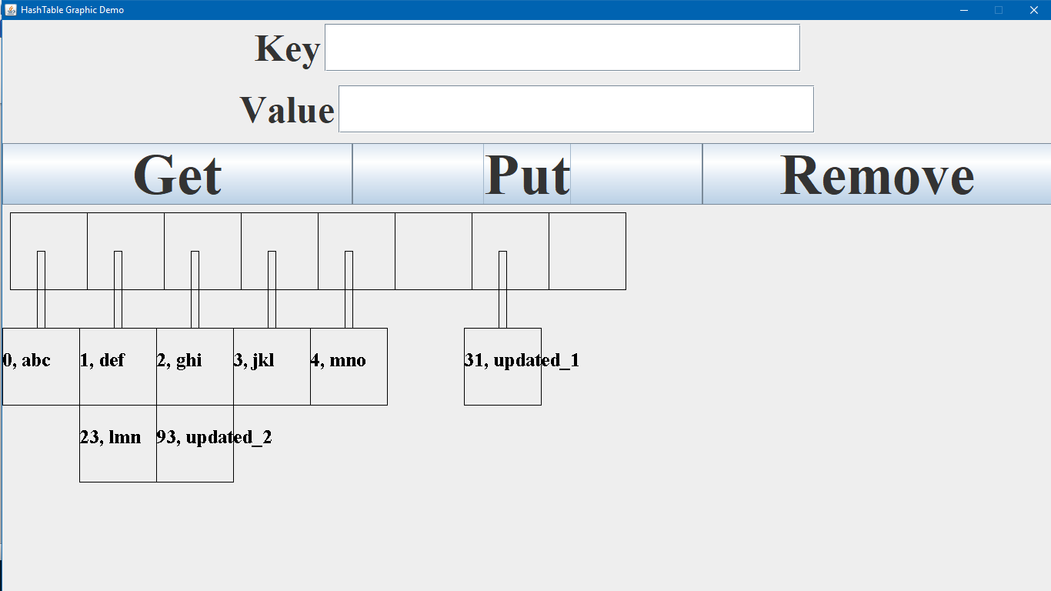

**Fig. SS_11 Put operation: Update value (Key = 93, Value = updated_2)**

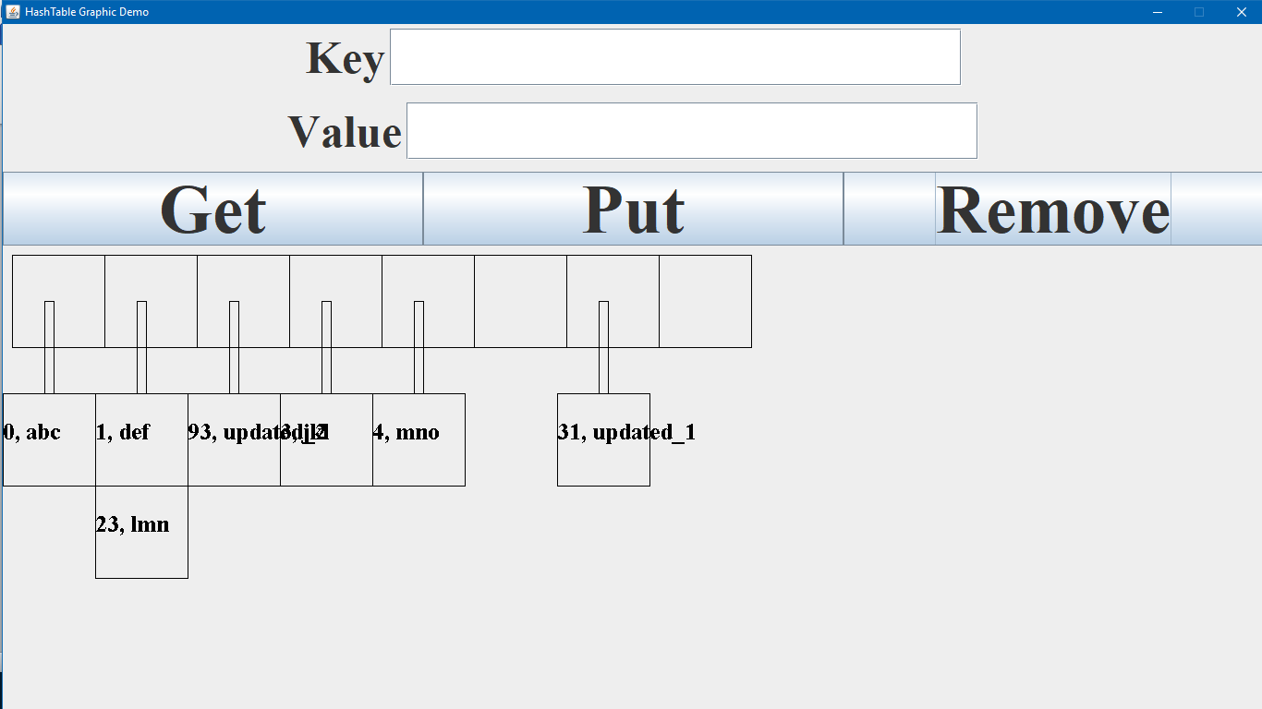

**Fig. SS_12 Remove operation (Key = 2)**

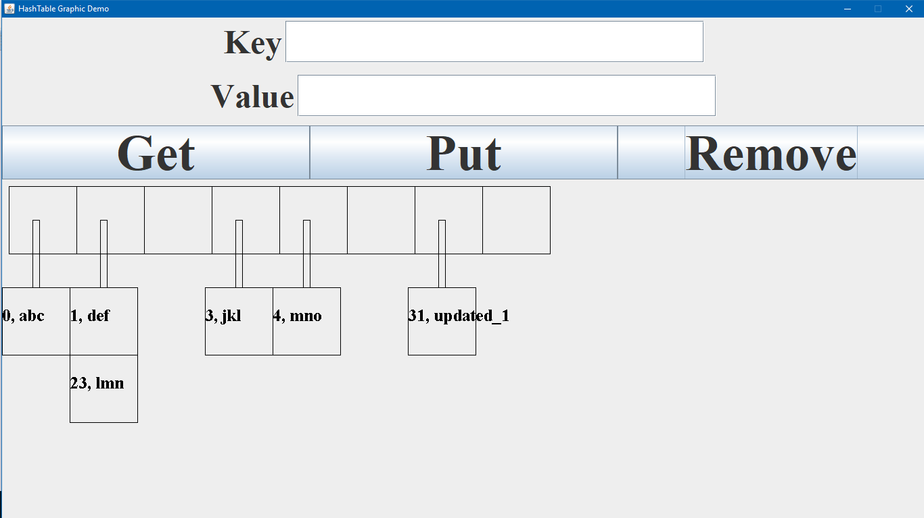

**Fig. SS_13 Remove operation (Key = 93)**

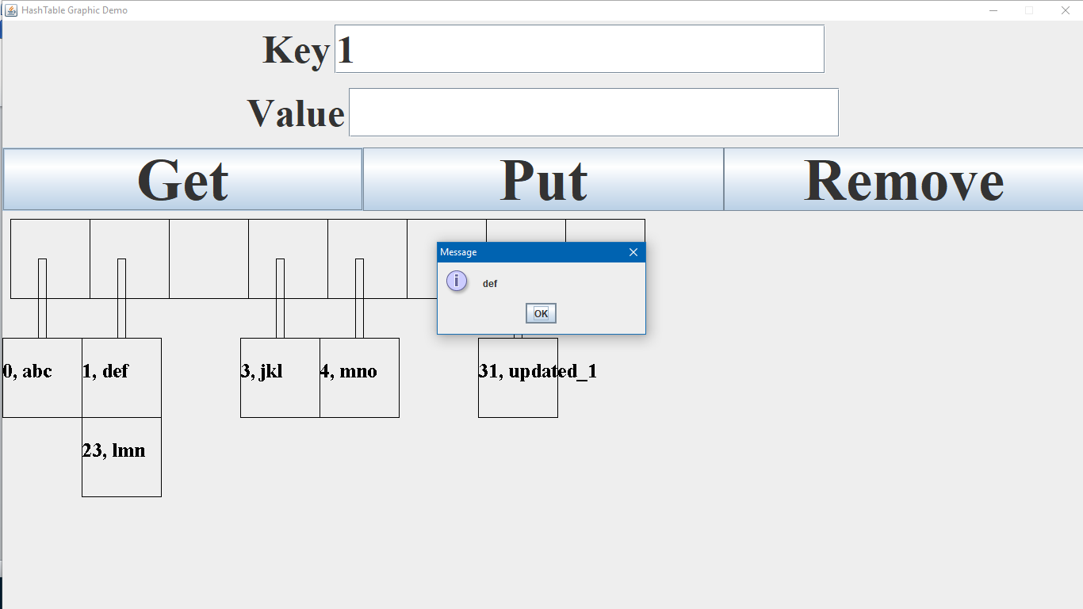

**Fig. SS_14 Get operation (Key = 1)**

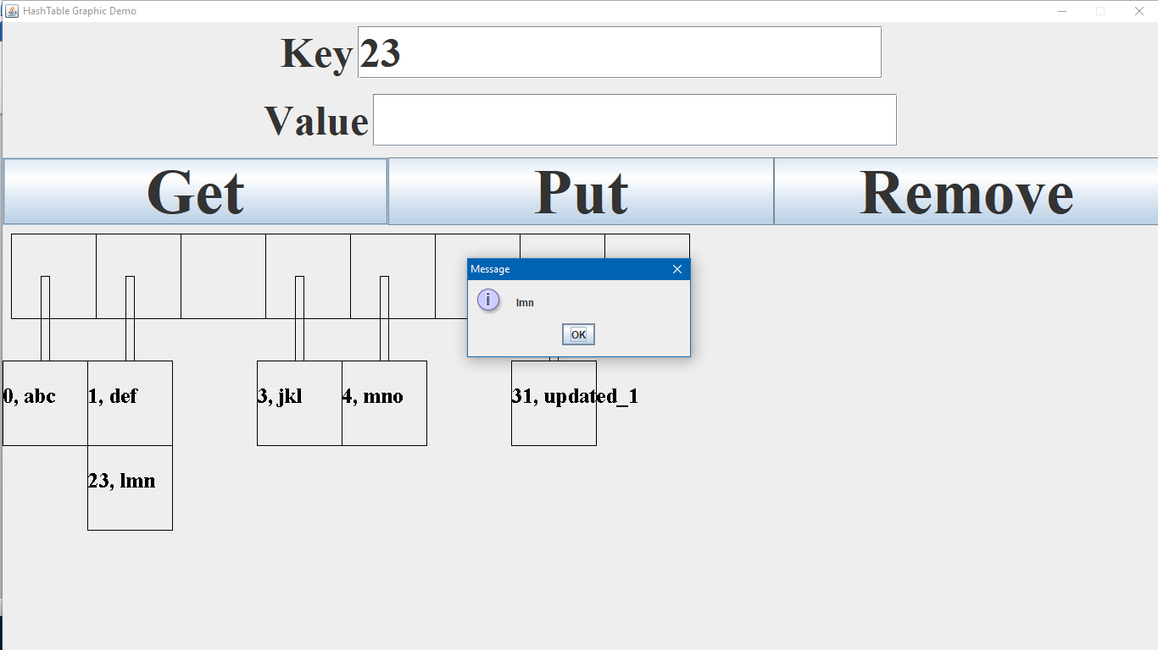

**Fig. SS_15 Get operation (Key = 23)**

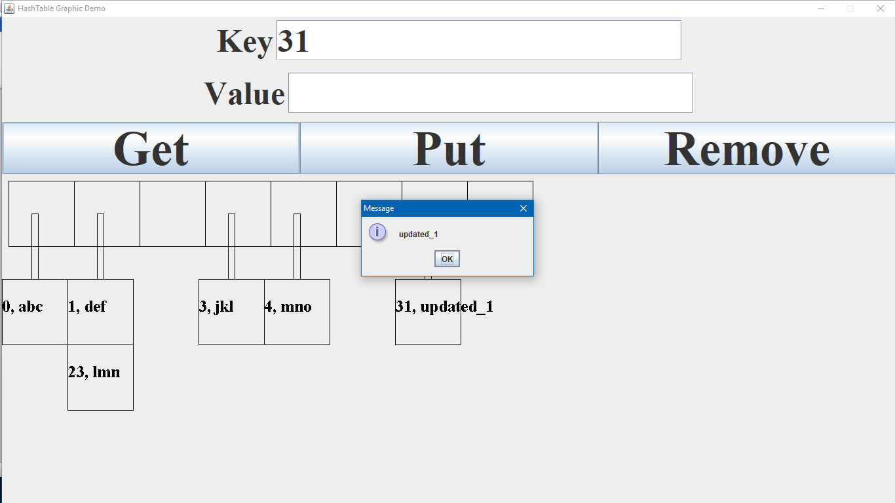

**Fig. SS_16 Get operation (Key = 31)**

This project is a humble attempt to explain the working of main functions of a HashMap and demonstrating what happens behind the scenes in these operations.